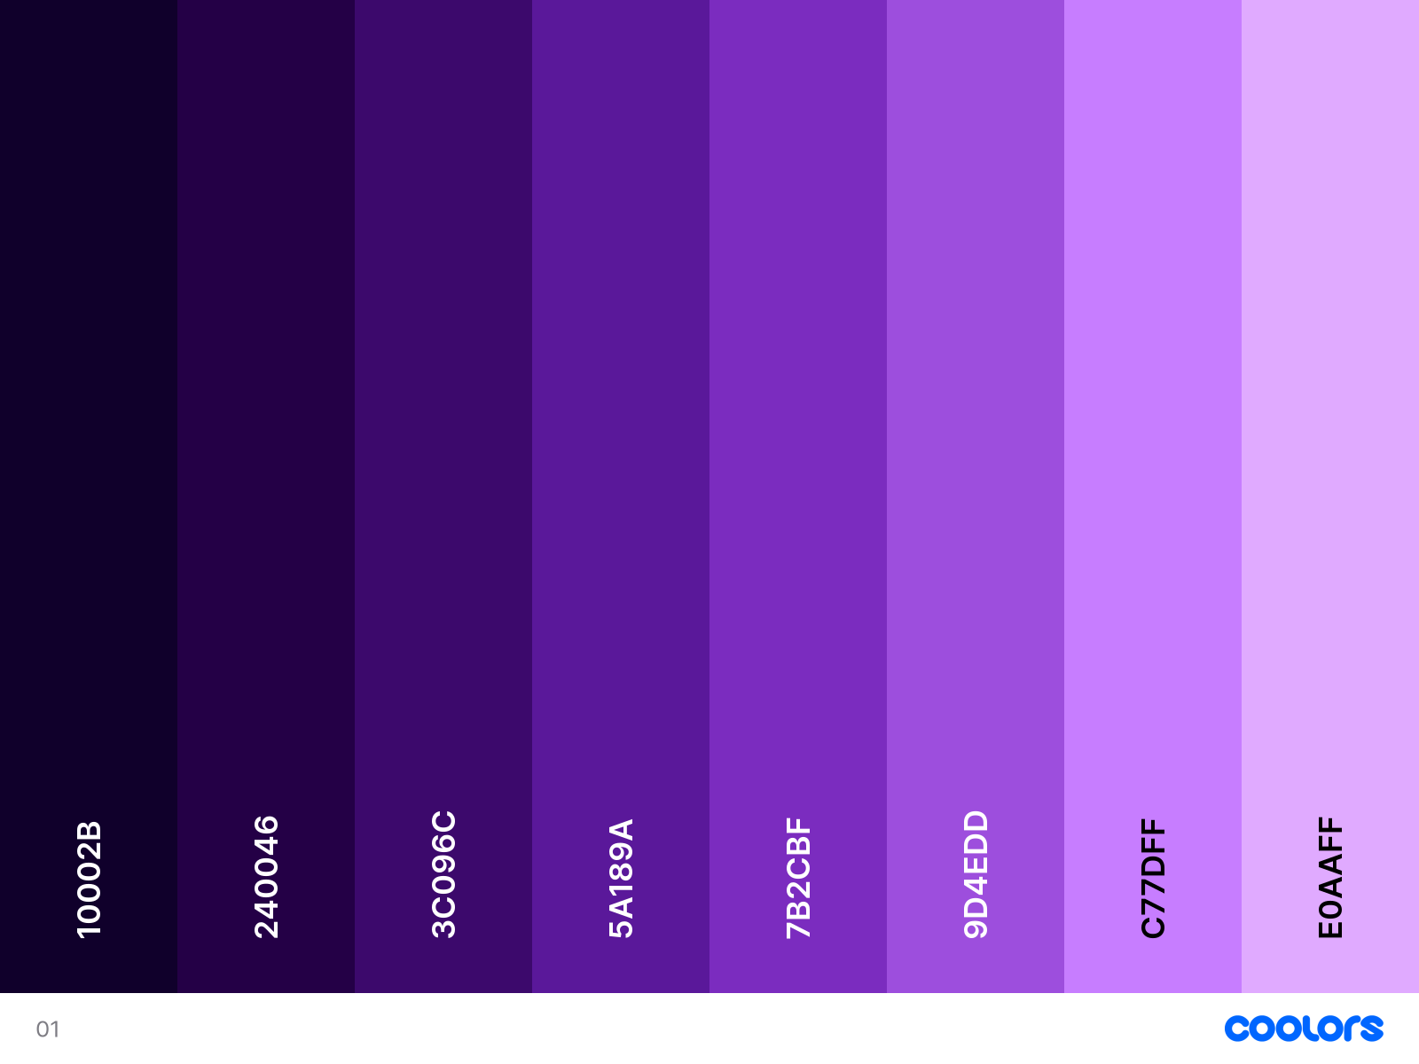

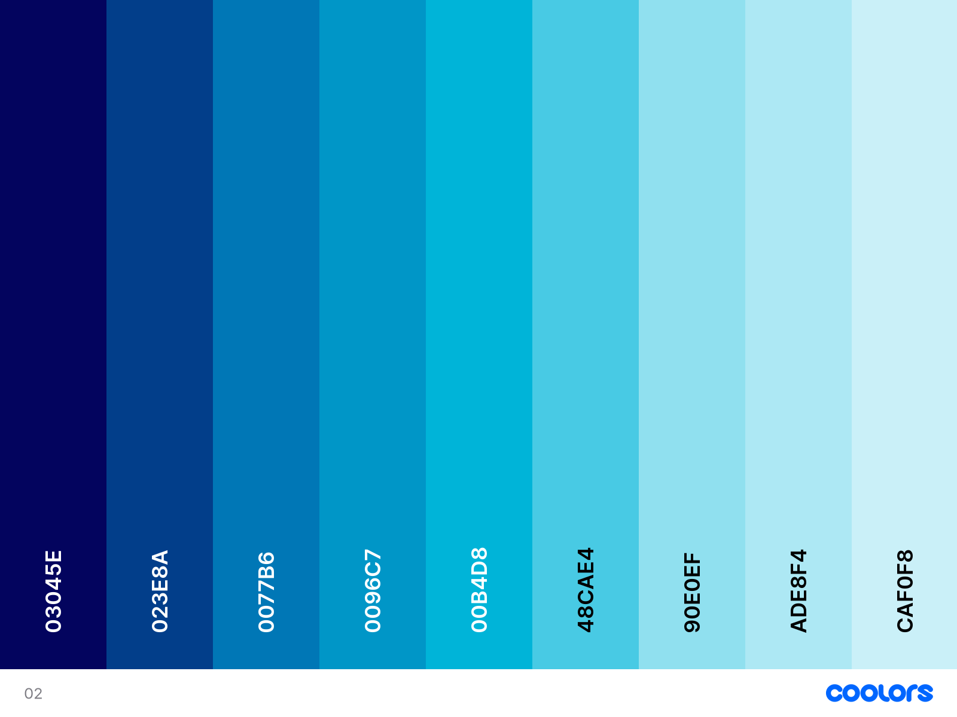

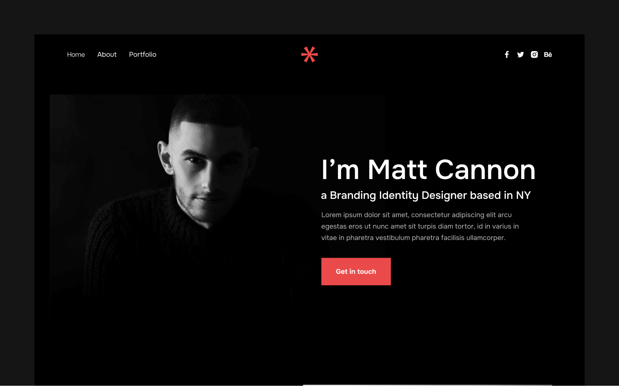

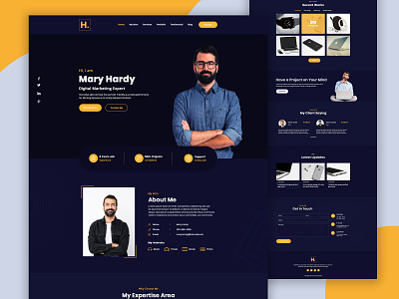

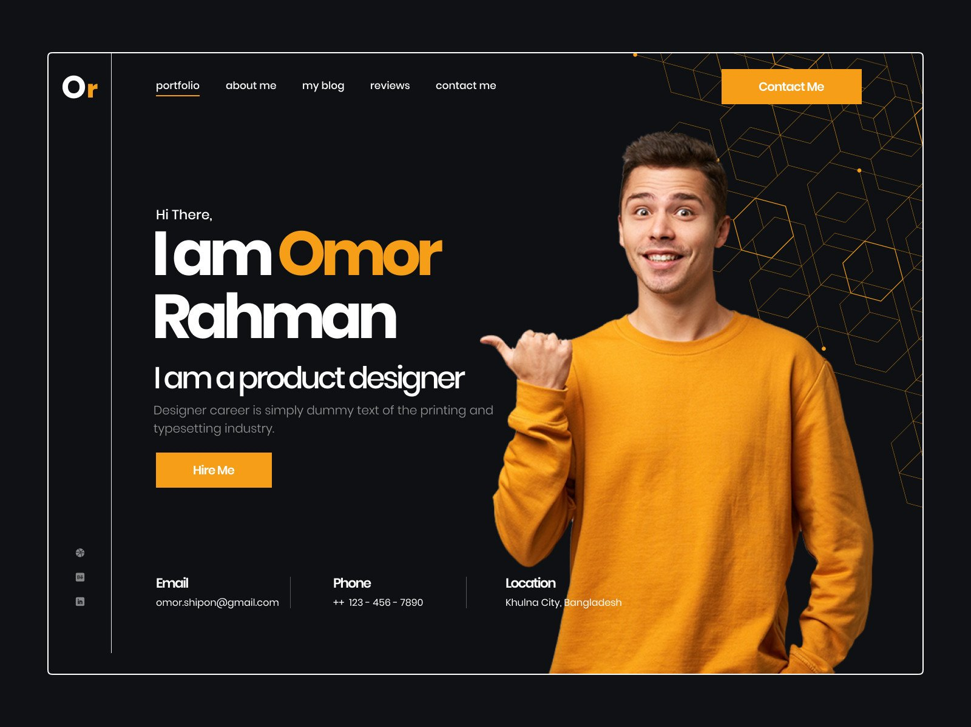

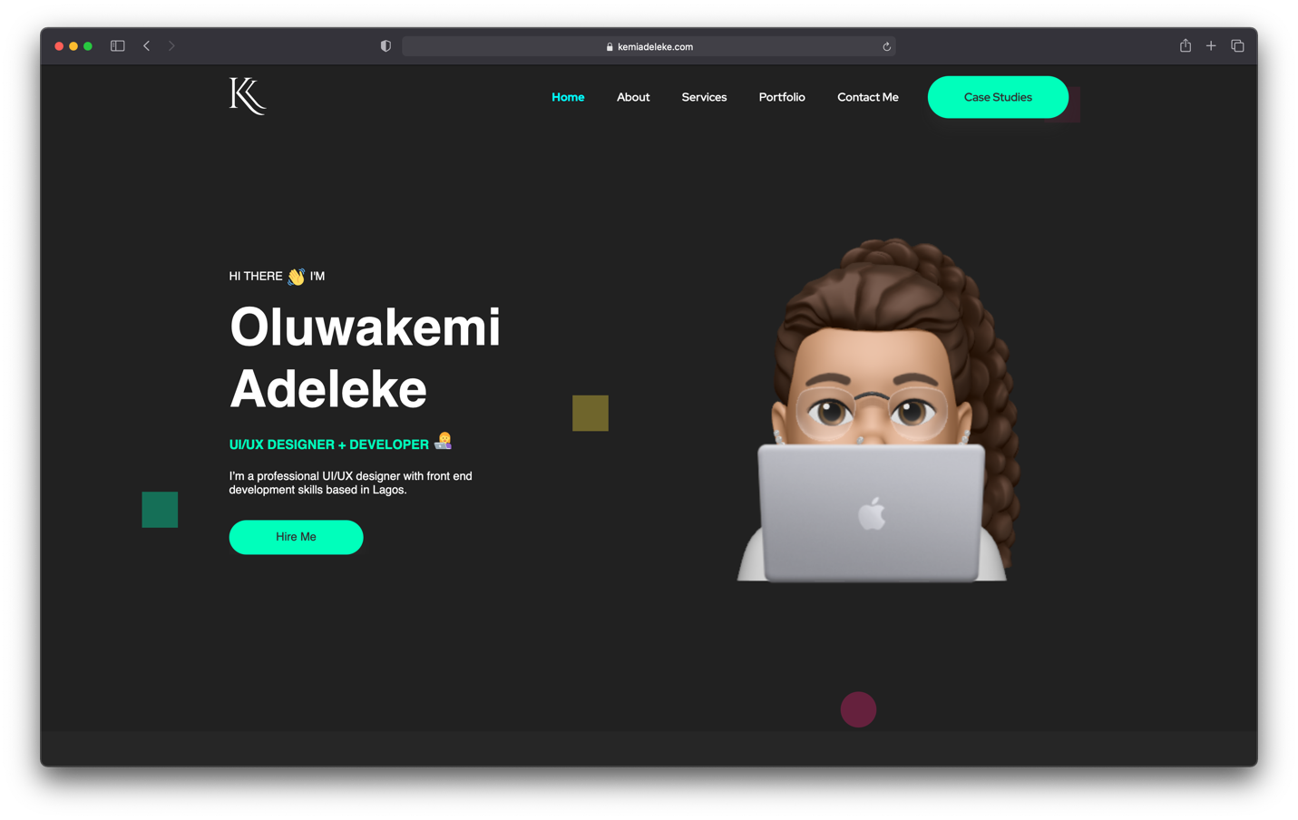

# Font

<https://fonts.google.com/specimen/Roboto+Flex?query=roboto>

# Others

<https://medium.com/erika-harano/ux-task-flows-versus-user-flows-as-demonstrated-by-pancakes-896e78a98026>